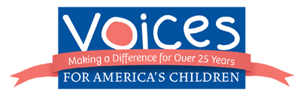

The “America’s Kids, America’s Future” Budget Campaign

The “America’s Kids, America’s Future” campaign is working to change the debate about the federal budget and beyond by challenging political leaders to create fiscal and social policy that invests in America’s most valuable asset – our kids.

Voices for America’s Children, with consulting, design and development support from social media experts at Fission Strategy, has launched this campaign to oppose cuts to children’s programs during the 2012 budget debate. Through a new Facebook app and a series of infographics, the campaign is educating its online audience about how the abstract numbers game in Washington has concrete effects on children and families across America. Infographics also are a great new way of storytelling, and Voices’ efforts have been highlighted by The Chronicle of Philanthropy and others.

During the short time the “America’s Kids, America’s Future” campaign has been active, more than 12,000 messages have been sent to Congress. Voices has increased its website viewers by 35 percent, increased its mentions on other organizations’ websites and blogs by 800 percent and quadrupled the number of “fans” on its Facebook page to more than 2,600.

The Voices Facebook app helps children in the budget fight by connecting concerned Americans to their representatives. Users simply enter a zip code to be matched with their members of Congress. From there, they can send them a message that children should be protected from short-sighted budget cuts.
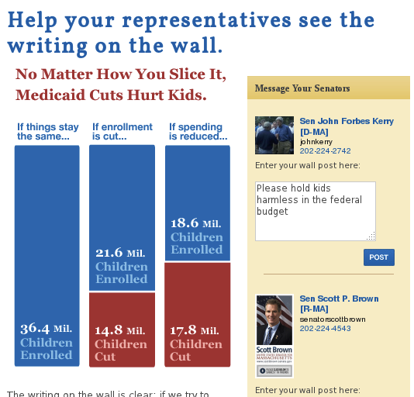

A screenshot of the Voices Facebook app
A series of infographics make the case against cuts to programs that American children rely on. By turning the arcane and abstract numbers of the budget process into a relatable visual, the infographics provide an accessible way to understand what is at stake for children. Included below are the infographics Voices has commissioned so far, showing the effects of poverty, proposed cuts to Medicaid, the Women, Infants and Children food assistance plan and Pell grants, as well as a call for new investment:

