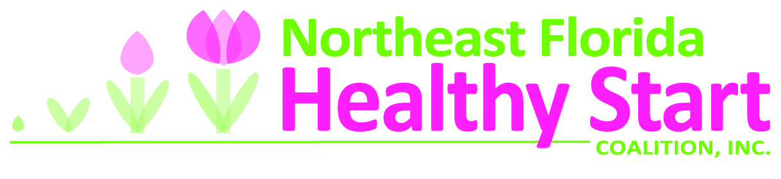

PRESS RELEASE
Contact: LaRonda Howard
Office: 904-723-5422 x114
E-mail: lhoward@nefhsc.org
For Immediate Release
September 3, 2014
NORTHEAST FLORIDA HEALTHY START COALITION TO HOST INAUGURAL JACKSONVILLE BABY BUGGY WALK IN THE PARK IN RECOGNITION OF INFANT MORTALITY AWARENESS MONTH
Moms and dads pushing babies in their buggies and community members will walk for the first time in honor of babies that died and to celebrate the babies that made it to their first birthday during National Infant Mortality Awareness Month, as part of a nationwide effort to bring attention to this important community issue and sentinel indicator of health.
On September 13, the Northeast Florida Healthy Start Coalition will host the city's first annual Baby Buggy Walk in the Park, a health festival and 2.2 mile fitness walk at the Magnolia Project, 5300 N. Pearl St., Jacksonville. This free family event will take place at 9 a.m. and provide an opportunity for families to come together for exercise and fun activities, receive valuable health information and screenings and enjoy a fun day in the park.
The event, which is taking place in major cities across 13 states, emphasizes the important role of parents and the community as a whole in preventing infant deaths and promoting health birth outcomes, particularly in minority communities. While the infant mortality rate is declining overall across the nation, rates still remain high in the Northeast Florida region, particularly among African American residents. In 2013 the Northeast Florida black and other nonwhite infant death rate, which typically is more than twice the white rate, decreased from 11.8 deaths per 1000 live births to 11.6 deaths, while the white rate is 6 deaths per 1000 live births. The racial gap is closing, but more work needs to be done to close it further and bring the overall infant death rate down.
"Our goal is to spread the word that planning for a healthy baby begins long before a mother sees her baby's face for the very first time," said Jennifer Gornto, Executive Director of the Northeast Florida Healthy Start Coalition. "Continuous prenatal care, healthy eating, physical activity, a healthy lifestyle, and family and community support are all crucial to ensuring that our youngest and most vulnerable have the best start in life." The Jacksonville event is one of 18 Baby Buggy Walk in the Park festivals happening in other cities across the nation this fall, calling attention to the link between healthy lifestyles, healthy families and healthy babies.
The inaugural Jacksonville event will take place at the Magnolia Project, a federal Healthy Start program in the Jacksonville urban core aimed at improving the health of women prior to pregnancy. The Magnolia Project is an initiative of the Northeast Florida Healthy Start Coalition, which leads a cooperative community effort to reduce infant mortality and improve the health of children, childbearing women and their families in Northeast Florida. During Infant Mortality Awareness Month, the Coalition is focusing on “What’s your role?”, as everyone has a role to play in making sure babies in the region are born healthy.
The Baby Buggy Walk in the Park launched in Baltimore in 2012 as a pilot project and became one of Baltimore Healthy Start's signature Infant Mortality Awareness Month activities. Last year, over 300 adults and children attended the Baltimore event, with more than 20 participating partners providing a range of health and family activities. This year, the National Healthy Start Association, with support from partners from around the country – including the U.S. Office of Minority Health Resource Center – engaged Healthy Start projects across the country to help make the Baby Buggy Walk in the Park a national event.
About Northeast Florida Healthy Start Coalition
The Healthy Start Coalition leads a cooperative community effort to reduce infant mortality and improve the health of children, childbearing women and their families in Northeast Florida. For more information visit NEFHealthyStart.org or Facebook.com/NEFHealthyStart
For more information about the Baby Buggy Walk it the Park and for a list of other participating cities, visit http://nefhealthystart.org/jacksonvillebabybuggywalk/.
Contact: LaRonda Howard
Office: 904-723-5422 x114
E-mail: lhoward@nefhsc.org

