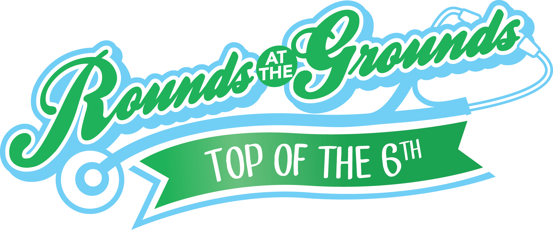
Charlene Shirk
Event Media Coordinator
904-860-2991
Charlene@charleneshirk.com
FOR IMMEDIATE RELEASE

Local All-Stars Take a Swing For a Healthy Start
6th Annual Rounds at the Grounds To Benefit Northeast Florida Healthy Start Coalition

(Jacksonville, FL) May 11, 2015 – Northeast Florida Healthy Start Coalition rounds up a team of local all-stars for its 6th annual Rounds at the Grounds charity softball game on Thursday, June 4, at 4:45 p.m. at Bragan Field. Tickets to the fundraising event are $10.50 and include admission to the Jacksonville Suns game immediately following the event.

Local celebrities and medical professionals face off in an hour-long softball game in hopes to raise funds and awareness regarding the importance of reducing the area’s high infant mortality rate and improving the health of women, children and families in Northeast Florida. Now in its sixth year, Rounds at the Grounds brings Northeast Florida Healthy Start Coalition’s mission to the turf of the Baseball Grounds of Jacksonville with the help of the following all-stars:

The 2015 Rounds at the Grounds Roster
- Michael Boylan, President & CEO, WJCT
- Donna Orender, CEO, Orender Unlimited, Founder of Generation W
- Melanie Lawson, WJXT News Anchor
- Bruce Hamilton, WJXT News Anchor
- Jennifer Waugh, WJXT News Anchor
- Matt Pittman, Matt About Jax
- Nikolai Vitti, Superintendent Duval County Schools
- Rachel Vitti, Community Advocate
- Robert Harmon
- Kerry Speckman, Writer, Blogger and Social(media)ite
- Stephen Topp, UF Health
- Charles Griggs, Florida Department of Health – Duval County
- Richard Ten Hulzen, Beaches Eye Center
- Michael Nussbaum, UF Health
- Leon Baxton, COO, Communities in Schools
- Harry Abram, Nemours
- Alva Roché-Green, Mayo Clinic
- Ryan Cudahy, Mayo Clinic
- Candy Hodgkins, CEO, Gateway Community Services (Mother, former Jaguars Tony Boselli)
- Apryl Shackelford, Dean of Students, Leadership Academy
- Al Emerick, Television Personality, Al Emerick Productions
- Dawn Emerick, Impact Partners

We are currently seeking additional sponsors for the Rounds at the Grounds’ “Top of the 6th” exhibition softball game. Current sponsors include: Wolfson Children’s Hospital, Southern Oak Insurance Company, Molina Healthcare, University of Florida Health, Mayo Clinic and Sunshine Health. To learn more about sponsorships, visit our website at www.nefhealthystart.org/rounds.

Tickets are available by contacting Sara Reiger at 904-723-5422 ext. 124 or srieger@nefhsc.org, or by visiting www.nefhealthystart.org/rounds.

About Northeast Florida Healthy Start Coalition, Inc.
The Northeast Florida Healthy Start Coalition, Inc. was organized in 1992 as part of a statewide network of community-based organizations to reduce Florida’s high infant mortality and improve the lives of pregnant women and their families. The group is governed by a volunteer board, which allocates state funding and provides oversight to local agencies that deliver services to pregnant women and families of newborns. The Coalition covers Baker, Clay, Duval, Nassau and St. Johns counties. For more information about Northeast Florida Healthy Start Coalition please go to nefhealthystart.org.

###

