Northeast Florida Healthy Start Coalition
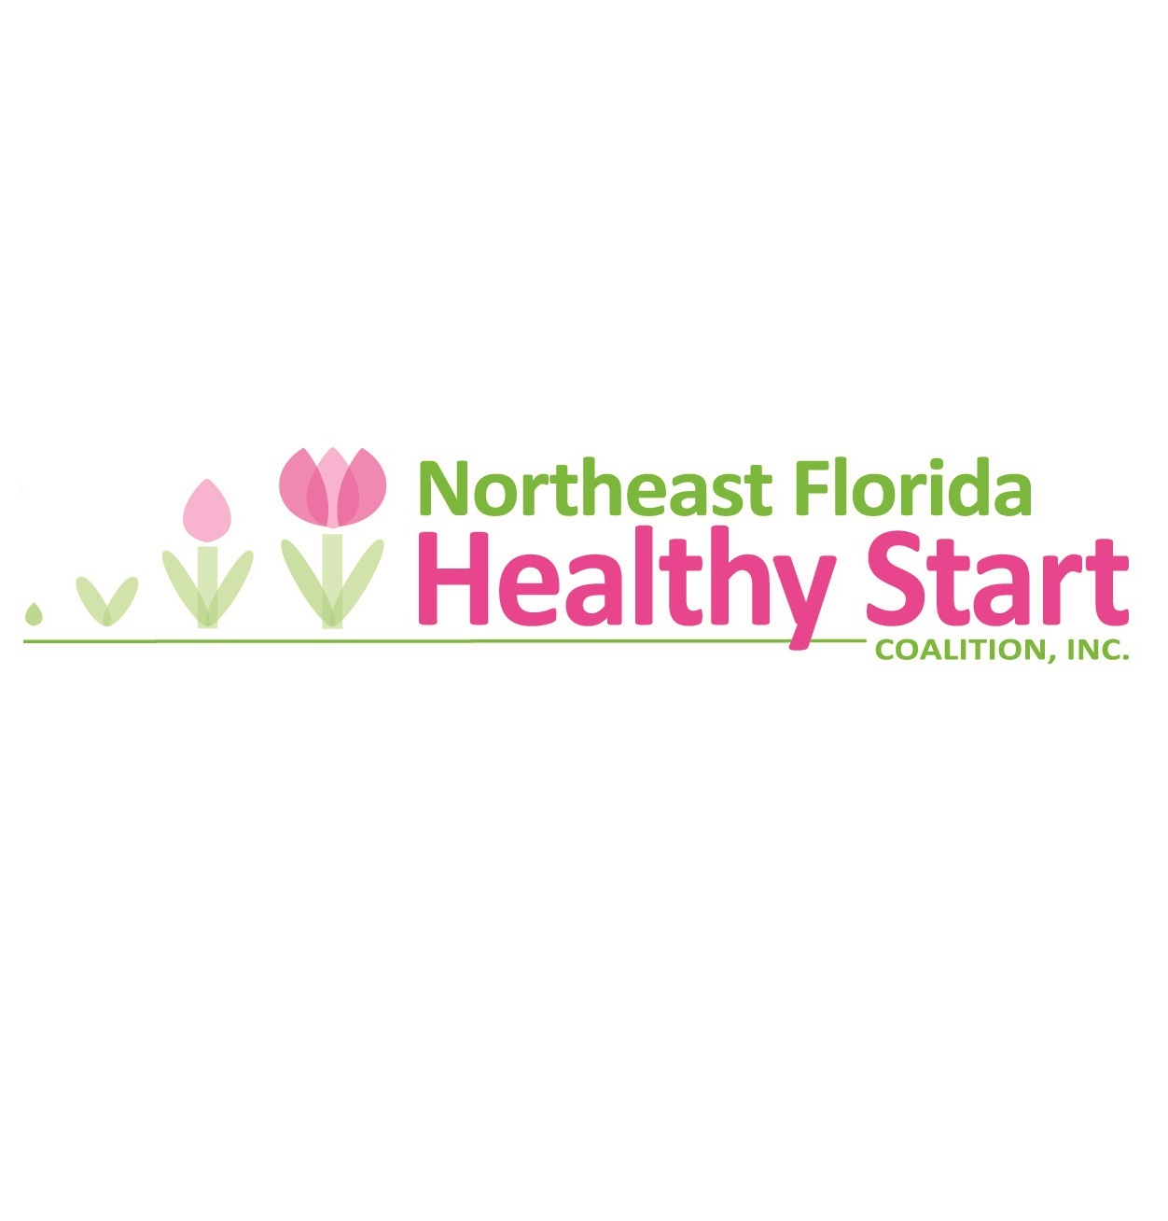o
Here

Job Description

Job title: Administrative Assistant and Intake Specialist
Work Location: Administration Building- 644 Cesery Building, Suite 210, Jacksonville, FL 32211
Division/Department: Admin
Reports to: Associate Executive Director
■ Full-time  □ Part-time | □ Exempt   Nonexempt
Essential Duties and Responsibilities:

Specific Activities includes:

- Meeting coordination and scheduling (coordinating space, making appointments, agenda development, scheduling guest speakers, record meeting minutes and calls for the Executive Director and Associate Executive Director and as needed)
- Preparing for and setting up meetings at multiple locations(sending out packets, confirming attendance, making copies, making coffee, and room set up)
- Perform work related errands as requested (dropping off packages or picking up supplies, etc.)
- Manage front desk (welcome visitors, answer and direct phone calls, check messages, process mail)
- Assist Coalition programs with special projects or initiatives, as needed
- Manage office responsibilities (Cell phone contact, IT company contact for issues and new equipment, telephone contact, check scanner contact, keep supply inventory and order, unpack, and organize program supplies, as needed, update and maintain inventory list with property tags, booking travel)
- Assist with Coordinated Intake and referral project (take minutes, coordinate meetings and triage potential clients to their appropriate programs)
- Assist with Healthy Start Medicaid resubmissions.
- Position requires reliable transportation, valid driver’s license, good driving record and automobile insurance.
- Must be able to travel to Baker, Clay, Duval, Nassau, and St. Johns counties.
- Assist with other duties as assigned by supervisor.
Qualifications:
REQURIED:
- HS Diploma or GED
- Minimum of 5 years of administrative assistant experience

PREFERRED:
- BA or BS Degree
- At least 5 years of experience in a social service setting

Skills:

- Excellent verbal and written communication skills, including ability to effectively communicate with internal and external clients.
- Experience or strong interest in Maternal and Child Health or non-profit work.
- Must be able to exhibit the following qualities; open minded, excellent organization skills, self motivated, flexible, friendly and professional demeanor and exceptional attention to detail.
- Excellent computer proficiency (MS Office – Word, Excel, PowerPoint and Outlook)
- Must be able to work under pressure, meet deadlines and prioritize while maintaining a positive attitude and providing exemplary customer service.
- Ability to work independently and to carry out assignments to completion within parameters of instructions given, prescribed routines, and standard accepted practices.
- Knowledge of health and human service providers.
- Ability to work traditional and nontraditional flexible hours.
- Ability to establish and maintain effective working relationships with Coalition partner agency staff and the general pubic.
- Professional appearance and demeanor.

Physical Requirements:
- Ability to safely and successfully perform the essential job functions consistent with the ADA, and other federal, state and local standards, including meeting qualitative and/or quantitative productivity standards.
- Must be able to talk, listen and speak clearly on telephone.
- Must be able to travel to alternate locations.
- While performing the duties of this job the employee is frequently required to sit, stand, walk, speak and hear. The position requires computer use so the employee must have sufficient hand dexterity to use a computer keyboard and be capable of reading a computer screen.

Print Employee Name:
Employee signature: Date:

Manager signature: Date:

